NoSQL DBMS

📂 What Is a NoSQL Database?
# Source: AI Source: Provided by: [Data Path: Persons Table -> ID Column: 1, Name_En Column: Motasem Essam] -> From: [ChatGPT] on [6/10/2026]
NoSQL stands for “Not Only SQL”.
It refers to a group of non-relational database systems that do not use traditional table-based structures like SQL databases (e.g., SQL Server, MySQL).

🔍 Core Concept
# Source: AI Source: Provided by: [Data Path: Persons Table -> ID Column: 1, Name_En Column: Motasem Essam] -> From: [ChatGPT] on [6/10/2026]
Instead of using tables with rows and columns, NoSQL databases store data in flexible formats like documents, key-value pairs, graphs, or wide-columns.
✅ This makes them ideal for:
- Handling large volumes of unstructured or semi-structured data
- Scalability across many servers (horizontal scaling)
- Use cases like real-time analytics, big data, and flexible JSON-like data models

🧩 Types of NoSQL Databases
# Source: AI Source: Provided by: [Data Path: Persons Table -> ID Column: 1, Name_En Column: Motasem Essam] -> From: [ChatGPT] on [6/10/2026]
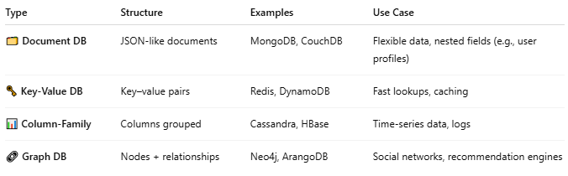
Type | Structure | Examples | Use Case
🗂 Document DB | JSON-like documents | MongoDB, CouchDB | Flexible data, nested fields (e.g., user profiles)
🗝 Key-Value DB | Key–value pairs | Redis, DynamoDB | Fast lookups, caching
📊 Column-Family | Columns grouped | Cassandra, HBase | Time-series data, logs
🔗 Graph DB | Nodes + relationships | Neo4j, ArangoDB | Social networks, recommendation engines

🆚 NoSQL vs SQL (RDBMS)
# Source: AI Source: Provided by: [Data Path: Persons Table -> ID Column: 1, Name_En Column: Motasem Essam] -> From: [ChatGPT] on [6/10/2026]
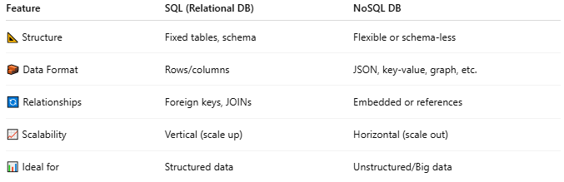
Feature | SQL (Relational DB) | NoSQL DB
📐 Structure | Fixed tables, schema | Flexible or schema-less
🧱 Data Format | Rows/columns | JSON, key-value, graph, etc.
🔄 Relationships | Foreign keys, JOINs | Embedded or references
📈 Scalability | Vertical (scale up) | Horizontal (scale out)
📊 Ideal for | Structured data | Unstructured/Big data

🧪 Real-Life Example: Document DB (MongoDB)
# Source: AI Source: Provided by: [Data Path: Persons Table -> ID Column: 1, Name_En Column: Motasem Essam] -> From: [ChatGPT] on [6/10/2026]
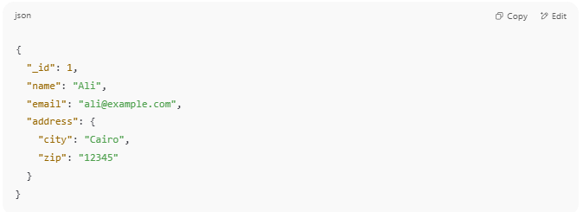
{
"_id": 1,
"name": "Ali",
"email": "ali@example.com",
"address": {
"city": "Cairo",
"zip": "12345"
}
}

This is a single document, not a row. Fields can be nested and vary between documents.

✅ When to Use NoSQL
# Source: AI Source: Provided by: [Data Path: Persons Table -> ID Column: 1, Name_En Column: Motasem Essam] -> From: [ChatGPT] on [6/10/2026]
- Rapid development with evolving schema
- Big Data / Analytics
- High-speed, high-volume apps (IoT, games, social media)
- Flexibility in data formats

🛠 Examples of NoSQL DBs by Category
# Source: AI Source: Provided by: [Data Path: Persons Table -> ID Column: 1, Name_En Column: Motasem Essam] -> From: [ChatGPT] on [6/10/2026]
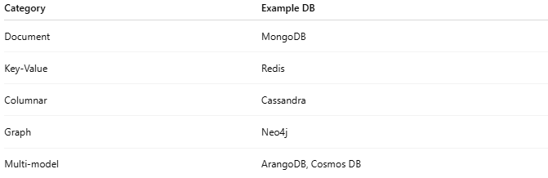
Category | Example DB
Document | MongoDB
Key-Value | Redis
Columnar | Cassandra
Graph | Neo4j
Multi-model | ArangoDB, Cosmos DB

✅ Summary
# Source: AI Source: Provided by: [Data Path: Persons Table -> ID Column: 1, Name_En Column: Motasem Essam] -> From: [ChatGPT] on [6/10/2026]
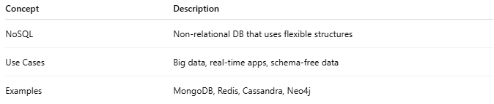
Concept | Description
NoSQL | Non-relational DB that uses flexible structures
Use Cases | Big data, real-time apps, schema-free data
Examples | MongoDB, Redis, Cassandra, Neo4j

Would you like help choosing between SQL vs NoSQL for your project? Or an example of how to use MongoDB with commands?

